Lab 4.8 Assignment

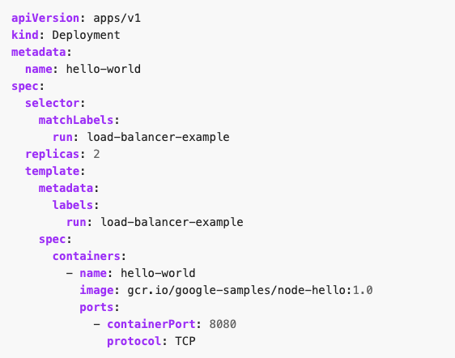

1. Run a Hello World application in your cluster: Create the application Deployment using the file above:

kubectl apply -f <yml file>

1. Display information about the Deployment:

kubectl get deployments hello-world

kubectl describe deployments hello-world

1. Display information about your ReplicaSet objects:

kubectl get replicasets

kubectl describe replicasets

1. Create a Service object that exposes the deployment:

kubectl expose deployment hello-world --type=NodePort --name=example-service

1. Display information about the Service:

kubectl describe services example-service

Make a note of the NodePort value for the service. For example, in the preceding output, the NodePort value is 31496.

1. List the pods that are running the Hello World application:

kubectl get pods -o wide

1. Use the node address and node port to access the Hello World application:

curl http://<public-node-ip>:<node-port>

****Disregard highlighted and do these steps instead if using minikube****

Start your minikube service (in Administrator Powershell):

minikube service example-service –url

While service is still running, In a separate terminal (can use command prompt OR open another powershell window) execute curl to access Hello World application:

curl http://<public-node-ip>:<node-port>

**NOTE**:Use the url address returned from previous execution, example of URL:

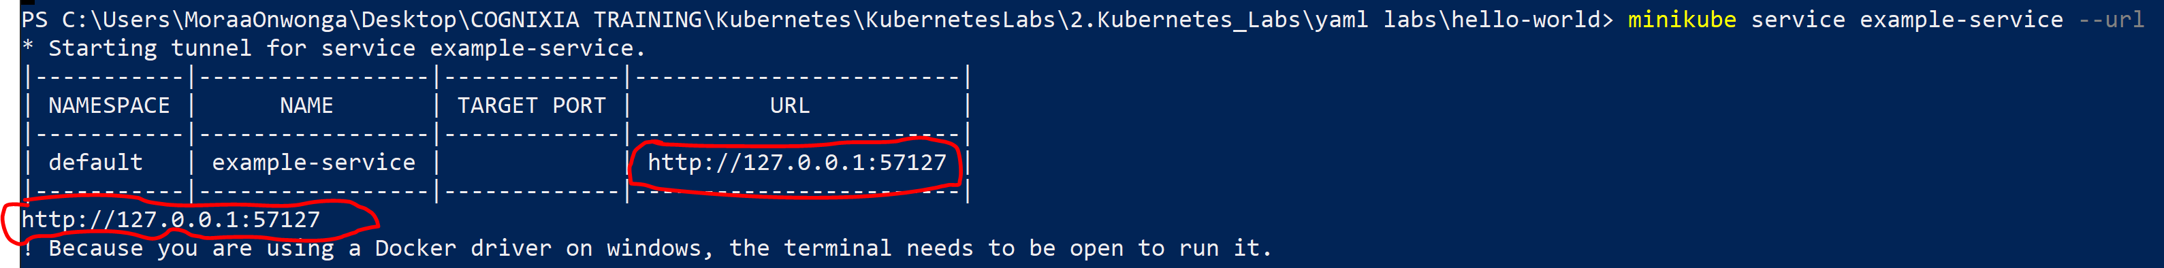

For this example you would execute: curl http://127.0.0.1:57127

where <public-node-ip> is the public IP address of your node, and <node-port> is the NodePort value for your service. The response to a successful request is a hello message:

Hello Kubernetes!

1. To delete the Service/ Deployment, enter this command:

kubectl delete services example-service

kubectl delete deployment hello-world